**Selenium Architecture:**

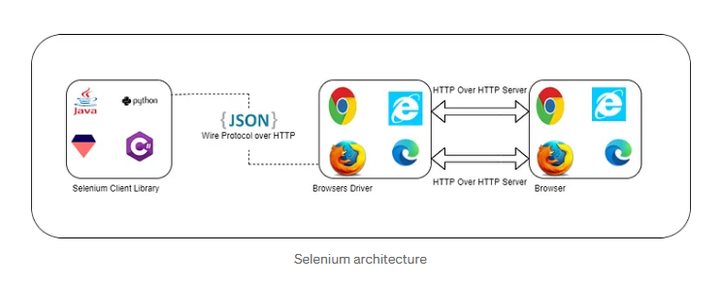

Selenium works on the HTTP connection protocol. It means after you trigger the test, the complete Selenium code written by us (Client) will be converted to JSON format. Generated JSON is sent to the browser driver (Server) through HTTP protocol.

# ****Playwright Architecture:****

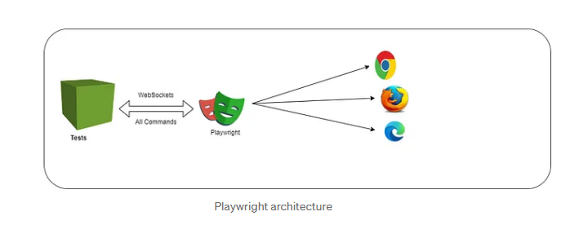

While Playwright works on Web socket connection protocol, it means once you will trigger the test, the code will be converted into JSON format and will be sent to the server using Web socket protocol.

**Difference between Web socket connection Protocol and HTTP connection protocol:**

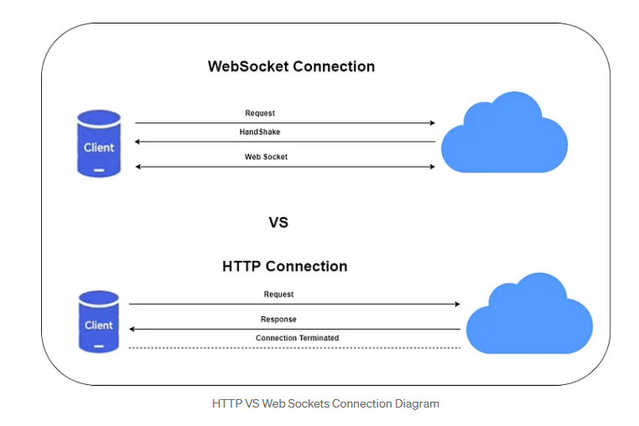

**Selenium** sends each command as a separate HTTP request and receives JSON responses. So, every action, such as opening the browser, clicking an element, or sending keys in a text box, is sent as a separate HTTP request. Additionally, after completion of every request, the connection between server and client will be terminated, which needed to be re-established for the next request.

Connection termination after every request result in slower execution which introduces a layer of flakiness.

**Playwright**, on the other hand, communicates all requests through a single Web socket connection, which stays in place until test execution is completed. This reduces the points of failure and allows commands to be sent quickly on a single connection.